Observation of transient linear coherent features under polarized optical conditions
Chur Chin
Department of Family Medicine, Dong-eui Medical Center, Busan 47227, Republic of Korea
Corresponding author: tpotaoai@gmail.com

Abstract
Transient linear optical features were observed under polarized illumination conditions using a smartphone-based imaging system and polarizing films. The observed structures exhibited brightness comparable to the central coherent spot and showed temporal evolution with environmental darkening. The phenomenon appeared strongest near an input polarization angle of 0°. The observations suggest the possibility of a non-random coherent optical effect associated with polarization alignment and moiré-like interference.

Introduction
Polarization-dependent optical interference frequently produces structured coherent patterns [1,2]. In simple imaging systems, transient linear features may emerge depending on the relative orientation of polarizing films, illumination geometry, and detector alignment [3]. Here, a preliminary observational study is reported using a compact smartphone imaging setup.
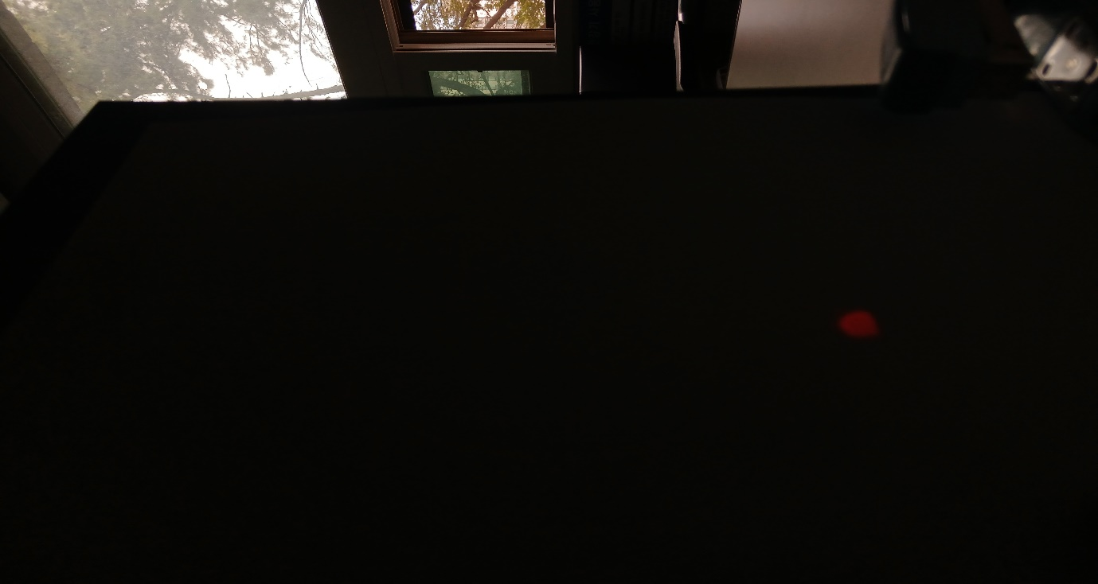Figure 1. Experimental optical configuration.
Suggested insertion site for a schematic of the smartphone camera, input polarizer, output polarizer, and observed optical path.

Experimental Method
A smartphone camera was aligned with a polarized optical configuration consisting of input and output polarizing films. The brightest input condition occurred at an input polarization angle of 0°. The output orientation producing the strongest signal corresponded to a rhombus-like double structure.
Observations were recorded between 18:00 and 20:00 local time under gradually decreasing ambient illumination.
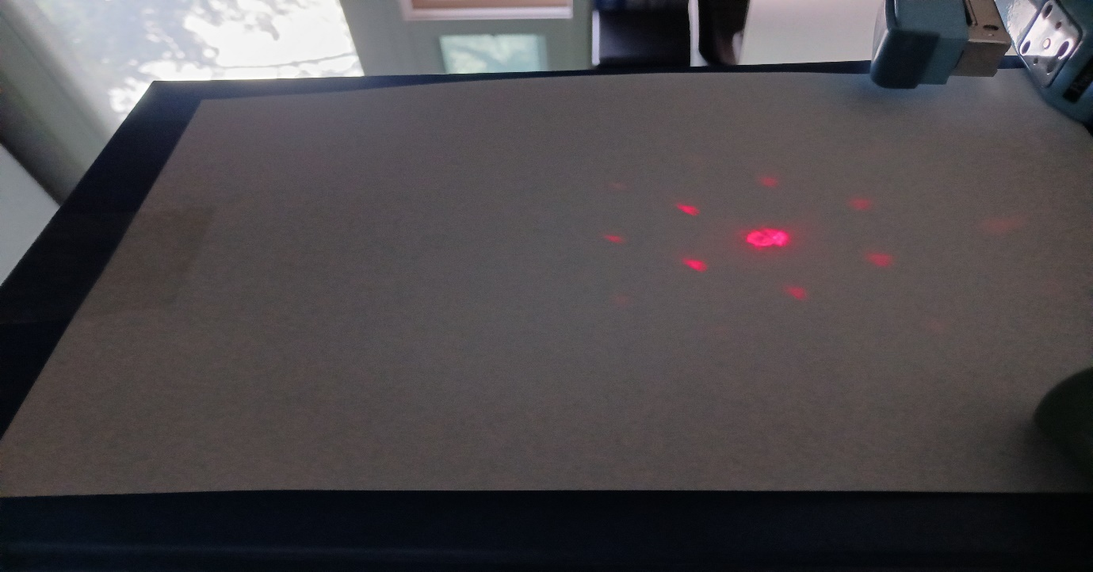Figure 2. Representative transient linear feature at 18:00.
Suggested insertion site for the observed bright linear coherent structure with brightness comparable to the central spot.

Results
At 18:00, a distinct linear feature was observed with brightness approximately equal to the central spot intensity. The line appeared stable and coherent.
At 19:00, the feature weakened substantially and disappeared as ambient conditions became darker.
At 20:00, no linear structure was visible. Subsequent moiré generation produced a satellite-like concentration pattern near the central circular region.
The observed morphology evolved from an elongated gourd-like structure into a concentrated central satellite configuration.
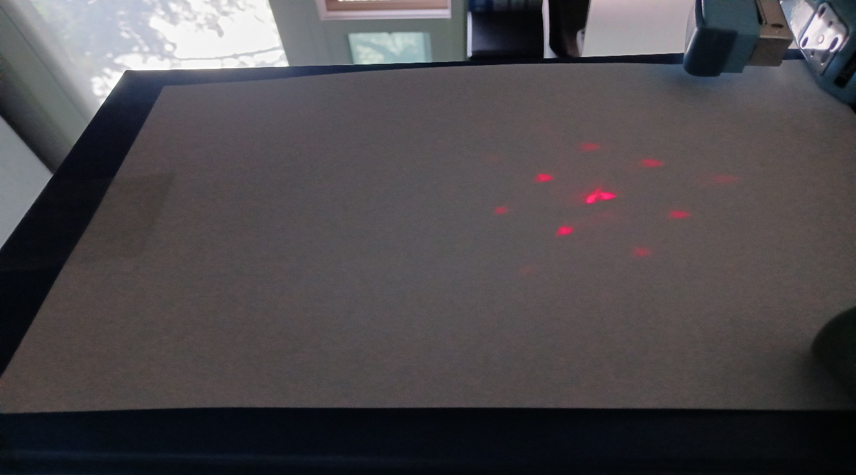Figure 3. Temporal evolution of the observed pattern.
Suggested insertion site for sequential images recorded at 18:00, 19:00, and 20:00 showing weakening and disappearance of the coherent line.
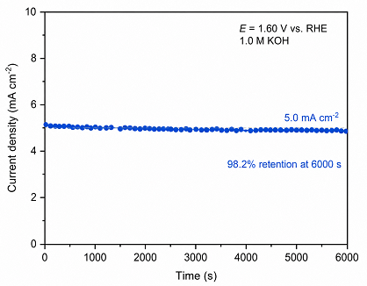
Figure 4. Moiré-induced satellite-like structure.
Suggested insertion site for the satellite concentration pattern observed after moiré generation.

Discussion
Polarization-dependent optical interference frequently produces structured coherent patterns. In simple imaging systems, transient linear features may emerge depending on the relative orientation of polarizing films, illumination geometry, and detector alignment. Here, a preliminary observational study is reported using a compact smartphone imaging setup.

Experimental Method
A smartphone camera was aligned with a polarized optical configuration consisting of input and output polarizing films. The brightest input condition occurred at an input polarization angle of 0°. The output orientation producing the strongest signal corresponded to a rhombus-like double structure.
Observations were recorded between 18:00 and 20:00 local time under gradually decreasing ambient illumination.

Results
At 18:00, a distinct linear feature was observed with brightness approximately equal to the central spot intensity. The line appeared stable and coherent.
At 19:00, the feature weakened substantially and disappeared as ambient conditions became darker.
At 20:00, no linear structure was visible. Subsequent moiré generation produced a satellite-like concentration pattern near the central circular region.
The observed morphology evolved from an elongated gourd-like structure into a concentrated central satellite configuration.

Discussion
The comparable brightness between the transient line and the central spot suggests that the feature may represent a coherent optical phenomenon rather than random detector noise. Temporal disappearance under reduced illumination may indicate sensitivity to alignment, coherence length, or polarization-dependent interference.
The later emergence of satellite-like structures following moiré formation supports the interpretation of structured interference effects within the optical pathway.
Further controlled experiments with calibrated polarization rotation, exposure stabilization, and environmental isolation are required.

Conclusion
A transient coherent linear optical feature was observed in a polarized smartphone-based imaging system. The phenomenon showed strong dependence on polarization orientation and ambient illumination conditions. Preliminary results indicate the possibility of structured coherent interference effects deserving additional investigation.

References
- M. Born and E. Wolf, Principles of Optics, 7th ed. (Cambridge University Press, Cambridge, 1999).
- E. Hecht, Optics, 5th ed. (Pearson, Boston, 2017).
- D. Goldstein, Polarized Light, 3rd ed. (CRC Press, Boca Raton, 2011).

Acknowledgments
A transient coherent linear optical feature was observed in a polarized smartphone-based imaging system. The phenomenon showed strong dependence on polarization orientation and ambient illumination conditions. Preliminary results indicate the possibility of structured coherent interference effects deserving additional investigation.

Acknowledgments
The author thanks informal image-analysis assistance used during preliminary observational review.

Data Availability
Experimental photographs and observational notes are retained by the author and may be available upon reasonable request.

